**Menoufia University**

**Faculty of Electronic Engineering**

**Embedded Systems (Lab.)**

**(Ultrasonic Sensor)**

**DEPARTMENT:**

* **Department of Engineering and Computer Science, 4rd year**

**STUDENT NAME:**

* **امجد مجدي فتحي سيد احمد**
* **سكشن (1)**
* **مجموعه (8)**

**Overview of ultrasonic sensor HC-SR04:**

**The HC-SR04 ultrasonic sensor uses sonar to determine the distance to an object. This sensor reads from 2cm to 400cm (0.8inch to 157inch) with an accuracy of 0.3cm (0.1inches), which is good for most hobbyist projects. In addition, this particular module comes with ultrasonic transmitter and receiver modules.**

**Wire connecting direct as following:**

* **5V Supply**
* **Trigger Pulse Input**
* **Echo Pulse Output**
* **0V Ground**

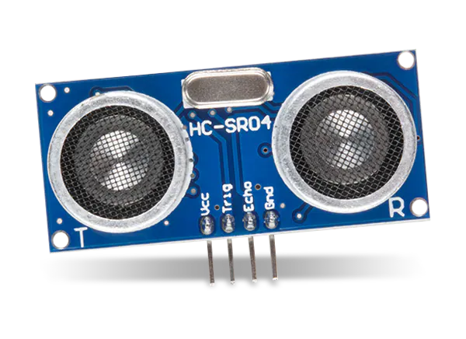

**Timing diagram and how does it work:**

**The Timing diagram is shown below. You only need to supply a short 10uS pulse to the trigger input to start the ranging, and then the module will send out an 8-cycle burst of ultrasound at 40 kHz and raise its echo. The Echo is a distance object that is pulse width and the range in proportion. You can calculate the range through the time interval between sending trigger signal and receiving echo signal.**

**Formula: uS / 58 = centimeters or uS / 148 =inch;**

**Or**

**Knowing the speed of sound in air (340 meters per second at room temperature), and considering that the sound wave travels to the object and back, the distance can be calculated using the formula:**

**Distance = (Time × Speed of Sound) / 2**

**Task #6 (ultrasonic sensor HC - SR04):**

**We will use an ultrasonic sensor of type HC - SR04 to determine the distance between an opponent and the sensor, and based on the distance, action will be taken.**

* **If the distance is greater than 3 meters, the LED is on**
* **If the distance is less than 3 meters, the LED will change and remain a blinking LED**
* **If the distance is less than 2 metres, the LED is blinking and the buzzer is working.**

**Required components for this lab:**

* **Breadboard**
* **Wires (male - male)**
* **1 ultrasonic sensor HC - SR04.**
* **1 buzzer.**
* **1 resistor in range of 100Ω to 1KΩ.**
* **1 led.**
* **1 resistor in range of 220Ω to 1KΩ.**

**Circuit diagram:**

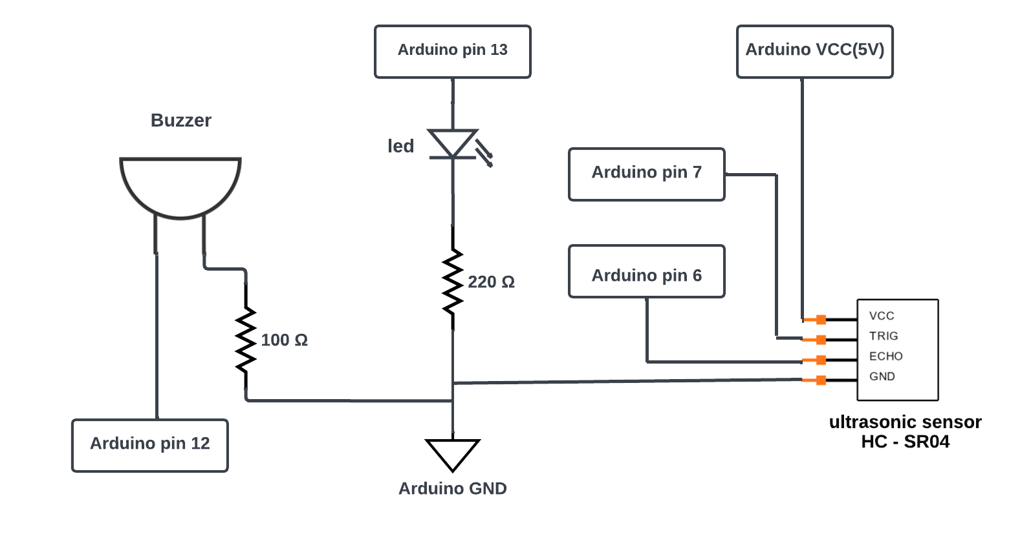

**Code:**

#define trig 7

#define echo 6

#define led 13

#define buzzer 12

long duration =0.0 ;

int distance = 0 ;

void setup() {

  pinMode(trig, OUTPUT);

  pinMode(echo, INPUT);

  pinMode(led, OUTPUT);

  pinMode(buzzer, OUTPUT);

**Serial**.begin(9600);

}

void loop() {

  digitalWrite(trig, LOW);

  delayMicroseconds(2);

  digitalWrite(trig, HIGH);

  delayMicroseconds(10);

  digitalWrite(trig, LOW);

  duration = pulseIn(echo, HIGH);

  distance= duration / 58;

  //distance= duration*0.034/2;

  if (distance > 300) {

    digitalWrite(led, HIGH);

    noTone(buzzer);     // Stop sound...

  } else if (distance > 200) {

    noTone(buzzer);     // Stop sound...

    digitalWrite(led, HIGH);

    delay(500);

    digitalWrite(led, LOW);

    delay(500);

  } else {

    tone(buzzer, 100 ,1000); // Send 100Hz sound signal...

    digitalWrite(led, HIGH);

    delay(300);

    digitalWrite(led, LOW);

    delay(300);

  }

**Serial**.print("Distance in CM: ");

**Serial**.println(distance);

}

**Simulation:**

**My Simulation to run code:** [**https://wokwi.com/projects/396978152238596097**](https://wokwi.com/projects/396978152238596097)